Using technology to enhance arrivals and departures

Oct. 22, 2019

Air traffic across Europe is at an all-time high and is set to increase. The SESAR 2020 Enhanced Arrivals and Departures project has been working on several solutions to increase airspace capacity and cost efficiency; improve safety and predictability and provide greater fuel efficiency and environmental sustainability.

The SESAR enhanced arrival and departures project (PJ01 EAD) addresses the development of concepts, tools and procedures to increase the capacity of extended TMAs (E-TMAs) to meet forecast traffic growth in a safe, cost-effective and environmentally sustainable manner. This is achieved by taking advantage of the latest technological developments from both an airborne and a ground-system perspective and through secure sharing of data.

The project partners have tested a new systemised airspace management tool (SYSMAN) and how it interacts with queue management systems especially Arrival Manager (AMAN), and Airport Demand Capacity Balancing (Airport-DCB).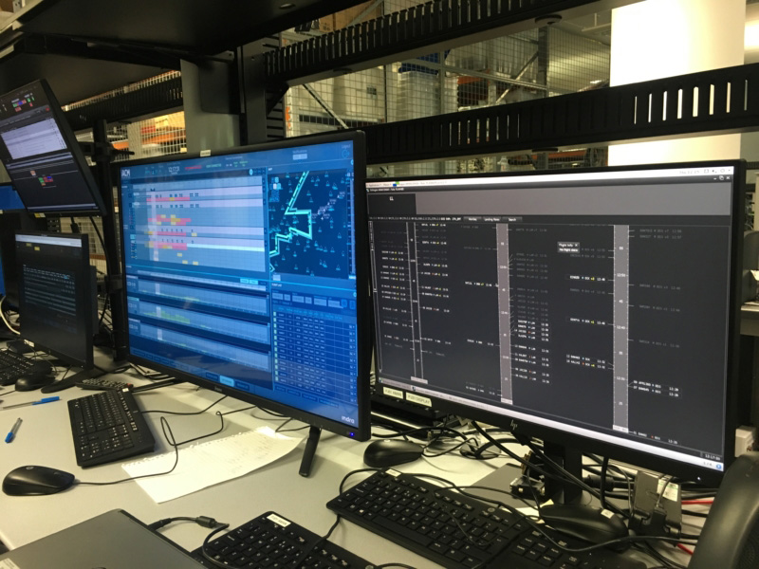

 “*Last year we carried out a fast-time simulation as part of the R&D for these solutions using three parallel inbound routes to the London TMA to manage excess Heathrow traffic from the East.  The simulation demonstrated the benefits of streaming to a coordination point and using SYSMAN to route balance. The results showed that with high traffic levels, the number of times capacity of a flow is exceeded significantly decreases with the use of the SYSMAN tool,*” said Sian Andrews, SESAR Solution Lead, NATS.

“*We also carried out a joint real-time simulation in March for the arrival scenario, complemented by an additional departure activity in June.  Participants to the validation thought that the concept could bring real benefits in managing increasing traffic levels more efficiently and gave positive feedback, in particular on the pseudo-radar map with time controlling scrollbar.*”

[**Read about the NATS blog**](https://nats.aero/blog/2019/10/using-technology-to-enhance-arrivals-and-departures/)

*This project has received funding from the SESAR Joint Undertaking under the European Union's Horizon 2020 research and innovation programme under grant agreement No 731864*